End-to-End Jenkins → ArgoCD → EKS GitOps Lab
A hands-on lab wiring a CI pipeline (Jenkins) to a GitOps deployment pipeline (ArgoCD) on Amazon EKS.
Github repo: https://github.com/letslearn207/frontend-app-argocd/
https://github.com/letslearn207/k8s-config
frontend-app-argocd — Holds the app source (app.js), Dockerfile, and the Jenkinsfile. Jenkins builds a Docker image from this repo, pushes it to Docker Hub, then updates and triggers the deploy.
k8s-config — Holds the Kubernetes manifests (deployment.yaml, service.yaml) that define how frontend actually runs in the cluster. Jenkins edits the image tag here after each build, and ArgoCD watches this repo to sync the cluster to match it.

Repos used
- App + CI: github.com/letslearn207/frontend-app-argocd (Dockerfile, Jenkinsfile, app.js)
- GitOps config: github.com/letslearn207/k8s-config (frontend/deployment.yaml, frontend/service.yaml)

Topology
- 1 machine — runs Jenkins (Docker), plus kubectl, aws cli, eksctl, argocd CLI, docker, git
- 1 EKS cluster — runs ArgoCD and the frontend app it deploys
Flow: commit to frontend-app-argocd → Jenkins builds & pushes image to Docker Hub → Jenkins updates k8s-config/frontend/deployment.yaml → Jenkins triggers argocd app sync → ArgoCD reconciles EKS.

0. Prerequisites
- AWS account + IAM credentials with EKS admin permissions
- A Docker Hub account — Jenkinsfile currently pushes to akshu20791/frontend; change this to your own username (Step 5)
- A GitHub Personal Access Token (classic, repo scope) with write access to k8s-config

1. Install tooling on the machine
# Docker
sudo apt update && sudo apt install -y docker.io git unzip
sudo usermod -aG docker $USER
newgrp docker

# AWS CLI v2
curl "https://awscli.amazonaws.com/awscli-exe-linux-x86_64.zip" -o "awscliv2.zip"
unzip awscliv2.zip && sudo ./aws/install
aws configure # enter your AWS access key, secret, region

# kubectl
curl -LO "https://dl.k8s.io/release/$(curl -L -s https://dl.k8s.io/release/stable.txt)/bin/linux/amd64/kubectl"
chmod +x kubectl && sudo mv kubectl /usr/local/bin/

# eksctl
curl --silent --location "https://github.com/eksctl-io/eksctl/releases/latest/download/eksctl_Linux_amd64.tar.gz" | tar xz -C /tmp
sudo mv /tmp/eksctl /usr/local/bin

# ArgoCD CLI
curl -sSL -o argocd https://github.com/argoproj/argo-cd/releases/latest/download/argocd-linux-amd64
chmod +x argocd && sudo mv argocd /usr/local/bin/

2. EKS cluster
If you already have one, just point kubectl at it:
aws eks update-kubeconfig --name <your-cluster-name> --region <your-region>
kubectl get nodes
If you need to create one (takes ~15 min):
eksctl create cluster \
--name jenkins-argocd-lab \
--region us-east-1 \
--nodegroup-name workers \
--node-type t3.medium \
--nodes 2 \
--managed
Verify:
kubectl get nodes

3. Install ArgoCD into EKS
kubectl create namespace argocd
kubectl apply -n argocd -f https://raw.githubusercontent.com/argoproj/argo-cd/stable/manifests/install.yaml

kubectl -n argocd get pods -w # wait until all pods are Running
Expose the ArgoCD API/UI via a LoadBalancer (simplest for a lab on EKS):
kubectl patch svc argocd-server -n argocd -p '{"spec": {"type": "LoadBalancer"}}'

# wait for the ELB hostname to populate:
kubectl get svc argocd-server -n argocd -w
Copy the EXTERNAL-IP hostname — this is your ARGOCD_SERVER. (wait for 5 mins then it will automatically start opening)
Get the initial admin password:
kubectl -n argocd get secret argocd-initial-admin-secret \
-o jsonpath="{.data.password}" | base64 -d && echo
Log in from the CLI:
argocd login <EXTERNAL-IP-from-above>:443 --username admin --password <password-from-above> --insecure

( If you get the output as argocd not found …then :
curl -sSL -o argocd https://github.com/argoproj/argo-cd/releases/latest/download/argocd-linux-amd64
ls -la argocd
chmod +x argocd
sudo mv argocd /usr/local/bin/argocd
which argocd
)

Optional: open the UI in a browser at https://<EXTERNAL-IP> — username admin, same password.

3a. Create the ArgoCD API token for Jenkins
ArgoCD only issues API tokens for accounts that have the “apiKey” capability enabled. The built-in admin account has it by default, so the fastest path works immediately — but it hands Jenkins full ArgoCD admin rights. For anything beyond a quick lab, create a scoped-down account instead.
Option A — Quick (built-in admin account)
kubectl patch configmap argocd-cm -n argocd --type merge \
-p '{"data":{"accounts.admin":"apiKey"}}'

kubectl rollout restart deployment argocd-server -n argocd

argocd account generate-token --account admin
# optional: add an expiry, e.g. --expires-in 8760h (1 year)
Simplest option for this lab. Downside: the token is equivalent to full ArgoCD admin — anyone with it can read/modify every Application, project, and cluster secret ArgoCD manages.
Option B — Recommended: a dedicated “jenkins” service account
1. Declare a new local account and give it the apiKey capability, via the argocd-cm ConfigMap:
kubectl patch configmap argocd-cm -n argocd --type merge \
-p '{"data":{"accounts.jenkins":"apiKey"}}'
2. Grant it just enough RBAC to sync/read the frontend app, via argocd-rbac-cm:
kubectl patch configmap argocd-rbac-cm -n argocd --type merge \
-p '{"data":{"policy.csv":"p, jenkins, applications, sync, */*, allow\np, jenkins, applications, get, */*, allow\n"}}'
3. Restart argocd-server so it picks up both ConfigMap changes:
kubectl rollout restart deployment argocd-server -n argocd
4. Generate the token for the jenkins account specifically (not admin):
argocd account generate-token --account jenkins --expires-in 8760h
This is the token that should go into the argocd-token credential in Jenkins. Scope the policy.csv rule down further (e.g. to a specific project instead of */*) once you have more than one app in the cluster.
Either way, save the token you generated — it's your argocd-token credential in Jenkins (Step 5b).

4. Register the ArgoCD Application
Your k8s-config repo doesn't have an ArgoCD Application resource yet. Add this file to it (also provided separately as argocd-application.yaml):
apiVersion: argoproj.io/v1alpha1
kind: Application
metadata:
name: frontend
namespace: argocd
spec:
project: default
source:
repoURL: https://github.com/letslearn207/k8s-config.git
targetRevision: main
path: frontend
destination:
server: https://kubernetes.default.svc
namespace: default
syncPolicy:
syncOptions:
- CreateNamespace=true
git clone https://github.com/letslearn207/k8s-config.git
cd k8s-config
# add argocd-application.yaml to the repo root (or wherever you keep it)
git add argocd-application.yaml
git commit -m "Add ArgoCD Application for frontend"
git push origin main
Apply it once so ArgoCD knows about the app:
kubectl apply -f argocd-application.yaml
argocd app get frontend
You should see it pointing at frontend/deployment.yaml and frontend/service.yaml in your k8s-config repo, currently OutOfSync (nothing's deployed yet). Sync it manually the first time to get a baseline running:
argocd app sync frontend
kubectl get pods,svc
You should see the frontend pods come up running image akshu20791/frontend:v1.0.16 (the current pinned tag in the repo).

5. Run Jenkins on the machine
docker run -d --name jenkins \
-p 8080:8080 -p 50000:50000 \
-v jenkins_home:/var/jenkins_home \
-v /var/run/docker.sock:/var/run/docker.sock \
-v $(which docker):/usr/bin/docker \
jenkins/jenkins:lts
Get the initial admin password and finish setup at http://<machine-ip>:8080:
docker exec jenkins cat /var/jenkins_home/secrets/initialAdminPassword
Install the suggested plugins, then also install Docker Pipeline and Git plugins (Manage Jenkins → Plugins) if not already present.

5a. Fix the Jenkinsfile before using it
Two things in your current Jenkinsfile need to point at your setup:
IMAGE_NAME = "akshu20791/frontend" // change to your Docker Hub username, e.g. "yourname/frontend"
ARGOCD_SERVER = "localhost:9090" // change to the ArgoCD EXTERNAL-IP:443 from Step 3
Push that change to frontend-app-argocd before running the pipeline.

5b. Add Jenkins credentials
Manage Jenkins → Credentials → (global) → Add Credentials, create these exact IDs (the Jenkinsfile references them by ID):
Credential ID | Type | Value
dockerhub-creds | Username/Password | Your Docker Hub username + password (or access token)
github-bot-token | Secret text | GitHub PAT with write access to k8s-config
argocd-token | Secret text | Token from `argocd account generate-token`

In Kubectl machine run:
stat -c '%g' /var/run/docker.sock
#copy the GID which appears
docker exec -u root jenkins groupadd -g <GID-from- last step> dockerhost
docker exec -u root jenkins usermod -aG dockerhost jenkins
docker restart jenkins
docker exec -u jenkins jenkins groups
## install argocd inside jenkins container (in kubectl machine)
docker exec -u root jenkins curl -sSL -o /usr/local/bin/argocd https://github.com/argoproj/argo-cd/releases/latest/download/argocd-linux-amd64
docker exec -u root jenkins chmod +x /usr/local/bin/argocd
docker exec -u jenkins jenkins argocd version –client

## go to jenkins file in https://github.com/letslearn207/frontend-app-argocd
Edit jenkinsfile
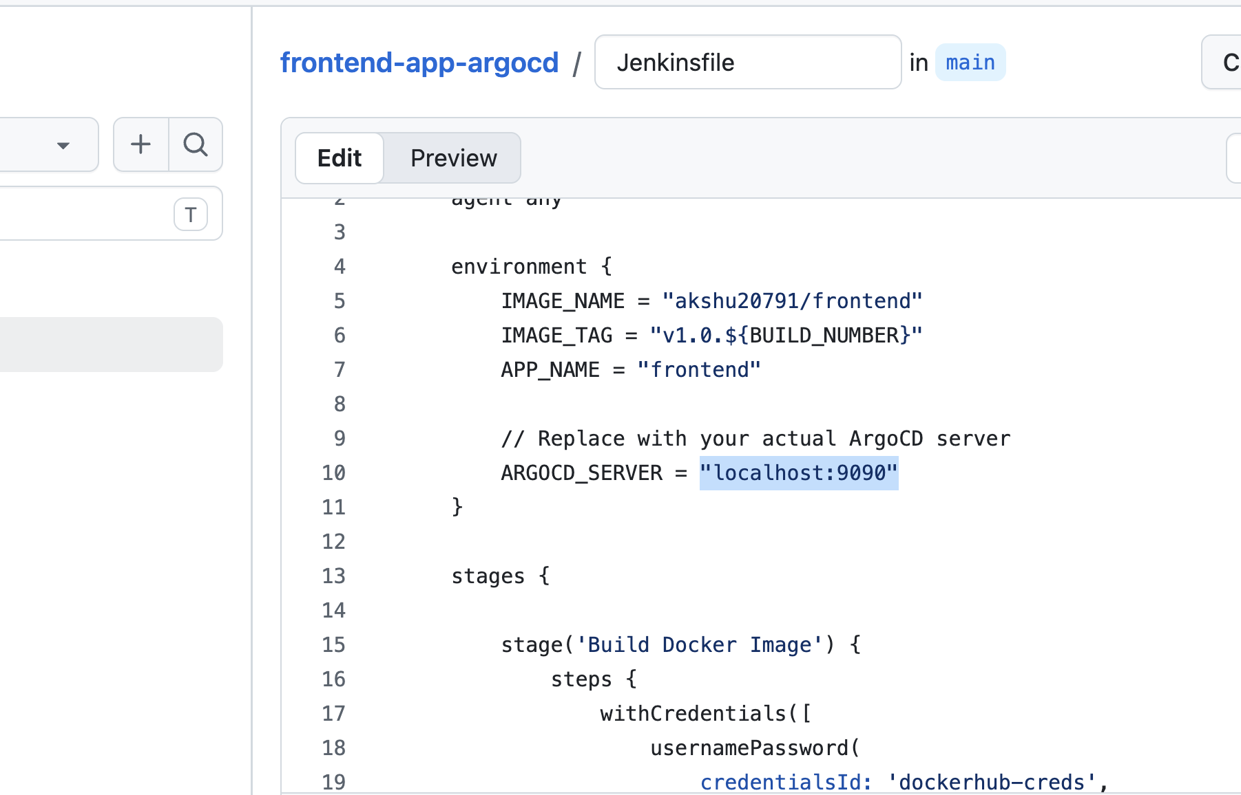
Update localhost:9090 with loadbalancerendpoint:443
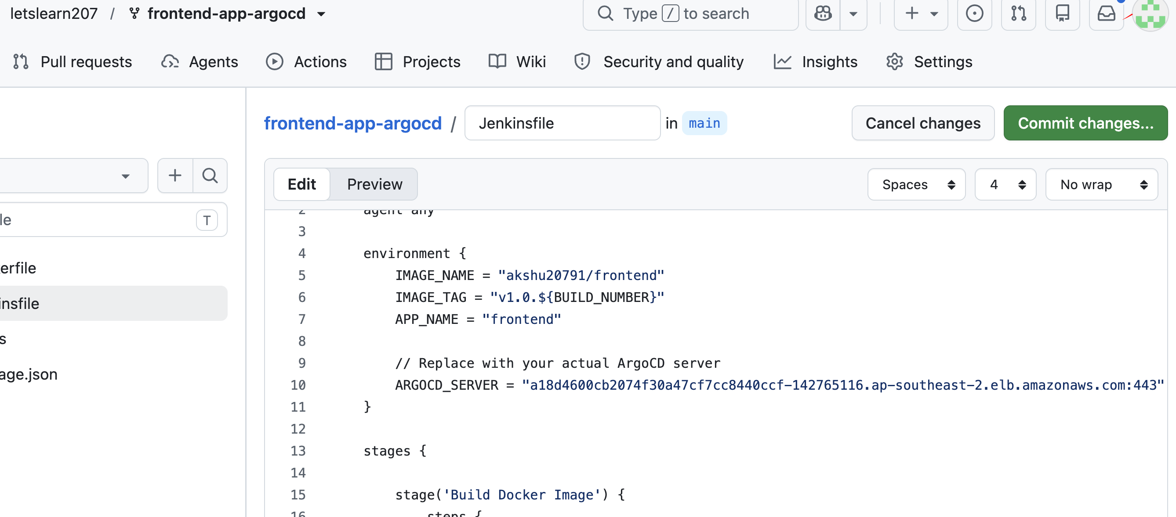

5c. Create the Jenkins pipeline job
- New Item → Pipeline → name it frontend-pipeline
- Pipeline → Definition: Pipeline script from SCM
- SCM: Git, Repository URL: https://github.com/letslearn207/frontend-app-argocd.git
- Script Path: Jenkinsfile
- Save

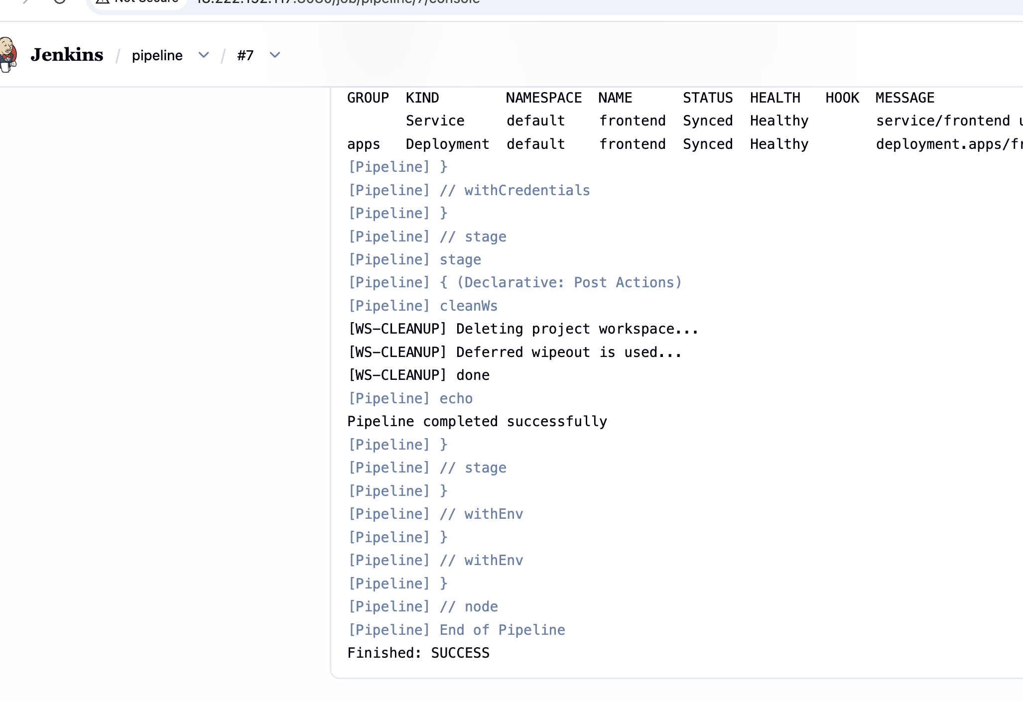

6. Run the end-to-end demo
- Trigger a build — click “Build Now” on frontend-pipeline (or push a commit to frontend-app-argocd to trigger it, if you wire up a webhook/poll).
- Watch the stages: Build Docker Image (builds and pushes <your-dockerhub>/frontend:v1.0.<BUILD_NUMBER>) → Update GitOps Repo (clones k8s-config, sed-replaces the image tag, commits, pushes to main) → Trigger ArgoCD Sync (calls argocd app sync frontend and waits).
- Verify in ArgoCD:
argocd app get frontend
You should see the new image tag and Synced / Healthy status.
- Verify in the cluster:
kubectl get deployment frontend -o jsonpath='{.spec.template.spec.containers[0].image}'
kubectl get pods -l app=frontend
- Verify in Git: check k8s-config/frontend/deployment.yaml on GitHub — the image: line should now show the new tag, committed by jenkins-bot.
- Hit the app:
kubectl port-forward svc/frontend 8081:80
curl http://localhost:8081
# -> "Hello from Jenkins-ArgoCD Demo"
That loop — a code change flowing through Jenkins into a Git commit into an ArgoCD-driven cluster update — is the whole GitOps story in one demo.

7. Cleanup (when you're done)
docker rm -f jenkins
kubectl delete -f argocd-application.yaml
kubectl delete namespace argocd
eksctl delete cluster --name jenkins-argocd-lab # only if you created it for this lab

Notes / things to double check before demoing live
- ARGOCD_SERVER and IMAGE_NAME in the Jenkinsfile are placeholders today — the pipeline will fail until you update them (Step 5a).
- ArgoCD sync policy is manual in the Application above, matching the Jenkinsfile's explicit argocd app sync call. If you want ArgoCD to also auto-detect drift, add an automated: { prune: true, selfHeal: true } block — good for showing “ArgoCD self-heals if someone kubectl-edits the cluster directly.”
- No resource requests/limits or probes on the Deployment — fine for a demo, but a nice callout if you want to show “day 2” hardening after the happy path works.
- Docker socket mount for Jenkins lets the Jenkins container build images using the host's Docker daemon — standard for single-machine Jenkins, but worth mentioning as a security tradeoff if this is a security-focused audience.

